Lab - Troubleshoot Redistribution

# Objectives

Troubleshoot network issues related to redistribution.

# Background / Scenario

In this topology D1, R1, and R2 are implementing OSPFv2. D1 is redistributing Loopback 0 into OSPFv2 area 10. R2 and R3 are BGP neighbors in AS 64512. You will be loading configurations with intentional errors or missing configurations onto the network. Your tasks are to FIND the error(s), document your findings and the command(s) or method(s) used to fix them, FIX the issue(s) presented here, and then test the network to ensure both of the following conditions are met:

* + - * 1. the complaint received in the ticket is resolved
        2. full reachability is restored

**Note**: The routers used with CCNP hands-on labs are Cisco 4221 with Cisco IOS XE Release 16.9.4 (universalk9 image). The switches used in the labs are Cisco Catalyst 3650 with Cisco IOS XE Release 16.9.4 (universalk9 image). Other routers, switches, and Cisco IOS versions can be used. Depending on the model and Cisco IOS version, the commands available and the output produced might vary from what is shown in the labs. Refer to the Router Interface Summary Table at the end of the lab for the correct interface identifiers.

**Note**: Make sure that the devices have been erased and have no startup configurations. If you are unsure, contact your instructor.

# Required Resources

* 3 Routers (Cisco 4221 with Cisco IOS XE Release 16.9.4 universal image or comparable)
* 2 Switches (Cisco 3560 with Cisco IOS XE Release 16.9.4 universal image or comparable)
* 1 PC (Choice of operating system with terminal emulation program installed)
* Console cables to configure the Cisco IOS devices via the console ports
* Ethernet cables as shown in the topology

# Instructions

## Trouble Ticket 17.1.2.1

Topology

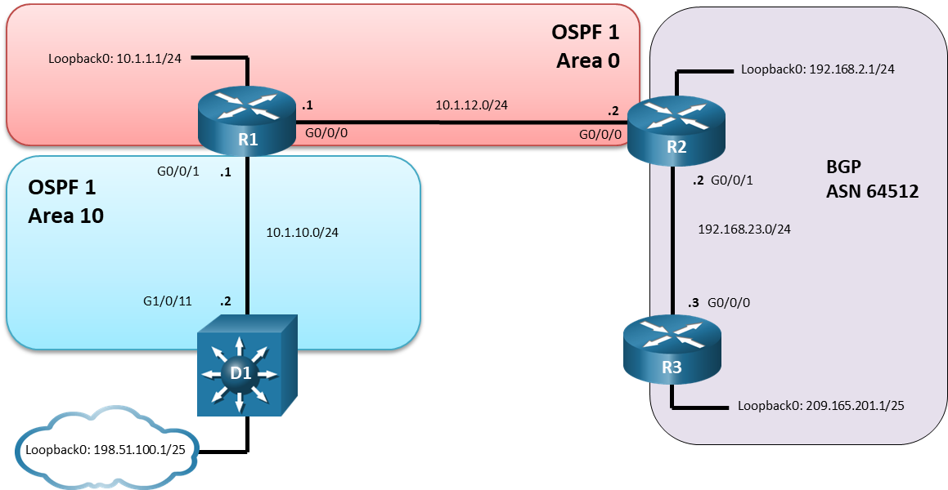

Addressing Table

| Device | Interface | IP Address | Subnet Mask |
| --- | --- | --- | --- |
| R1 | G0/0/0 | 10.1.12.1 | 255.255.255.0 |
| R1 | G0/0/1 | 10.1.10.1 | 255.255.255.0 |
| R1 | Loopback 0 | 10.1.1.1 | 255.255.255.0 |
| R2 | G0/0/0 | 10.1.12.2 | 255.255.255.0 |
| R2 | G0/0/1 | 192.168.23.2 | 255.255.255.0 |
| R2 | Loopback 0 | 192.168.2.1 | 255.255.255.0 |
| R3 | G0/0/0 | 192.168.23.3 | 255.255.255.0 |
| R3 | Loopback 0 | 209.165.201.1 | 255.255.255.128 |
| D1 | G1/0/11 | 10.1.10.2 | 255.255.255.0 |
| D1 | Loopback 0 | 198.51.100.1 | 255.255.255.128 |

Scenario:

During a routine maintenance window, router R2 was replaced and upgraded to support gigabit interfaces. Instead of modifying the previous R2 configuration to support gigabit interfaces and loading the configuration file on R2, the network engineer decided to type the IOS commands on R2 from memory. As a result, only partial redistribution is occurring between OSPFv2 and BGP. The network engineer requested your help in diagnosing and resolving the issue(s) to restore full connectivity.

Use the commands listed below to load the configuration files for this trouble ticket:

|  |  |
| --- | --- |
| Device | Command |
| R1 | **copy flash:/enarsi/17.1.2.1-r1-config.txt run** |
| R2 | **copy flash:/enarsi/17.1.2.1-r2-config.txt run** |
| R3 | **copy flash:/enarsi/17.1.2.1-r3-config.txt run** |
| D1 | **copy flash:/enarsi/17.1.2.1-d1-config.txt run** |

* Passwords on all devices are **cisco12345**. If a username is required, use **admin**.
* After you have fixed the ticket, change the MOTD on EACH DEVICE using the following command

**banner motd # This is $(hostname) FIXED from ticket <ticket number> #**

* Save the configuration by issuing the **wri** command (on each device).
* Inform your instructor that you are ready for the next ticket.
* After the instructor approves your solution for this ticket, issue the **reset.now** privileged EXEC command**.** This script will clear your configurations and reload the devices.

## Trouble Ticket 17.1.2.2

Topology

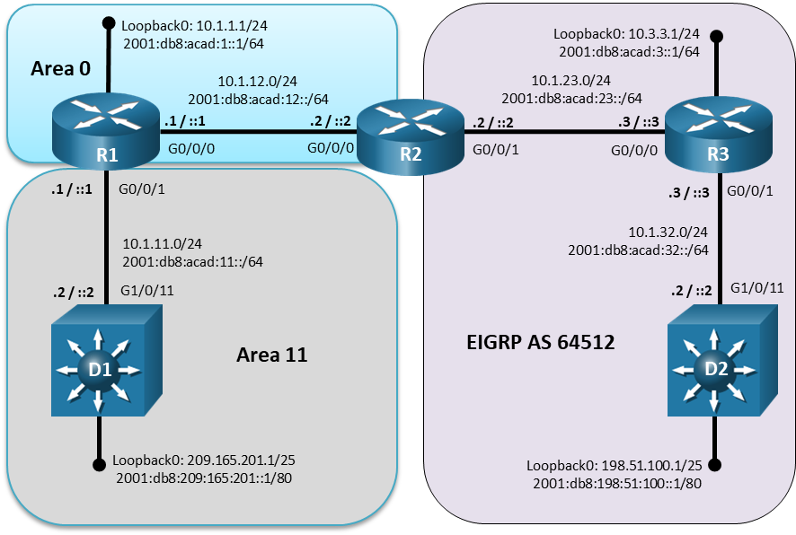

**Addressing Table**

| Device | Interface | IPv4 Address/Mask | IPv6 Address/Prefix | IPv6 Link Local |
| --- | --- | --- | --- | --- |
| R1 | G0/0/0 | 10.1.12.1/24 | 2001:db8:acad:12::1/64 | fe80::12:1 |
| R1 | G0/0/1 | 10.1.11.1/24 | 2001:db8:acad:11::1/64 | fe80::11:1 |
| R1 | Loopback 0 | 10.1.1.1/24 | 2001:db8:acad:1::1/64 | fe80::1:1 |
| R2 | G0/0/0 | 10.1.12.2/24 | 2001:db8:acad:12::2/64 | fe80::12:2 |
| R2 | G0/0/1 | 10.1.23.2/24 | 2001:db8:acad:23::2/64 | fe80::23:2 |
| R3 | G0/0/0 | 10.1.23.3/24 | 2001:db8:acad:23::3/64 | fe80::23:3 |
| R3 | G0/0/1 | 10.1.32.1/24 | 2001:db8:acad:32::3/64 | fe80::32:3 |
| R3 | Loopback 0 | 10.3.3.3/24 | 2001:db8:acad:3::3/64 | fe80::3:3 |
| D1 | G1/0/11 | 10.1.11.2/24 | 2001:db8:acad:11::2/64 | fe80::11:2 |
| D1 | Loopback 0 | 209.165.201.1/25 | 2001:db8:209:165:201::1/80 | fe80::209:1 |
| D2 | G1/0/11 | 10.1.32.2/24 | 2001:db8:acad:32::2/64 | fe80::32:2 |
| D2 | Loopback 0 | 198.51.100.1/25 | 2001:db8:198:51:100::1/80 | fe80::198:1 |

Scenario:

R2 is performing route redistribution between OSPFv3 AF and Named EIGRP for IPv4 and IPv6. During a routine maintenance window, router R2 was upgraded. As a result, redistribution is not occurring for IPv4 between OSPFv3 and named EIGRP.

Use the commands listed below to load the configuration files for this trouble ticket:

|  |  |
| --- | --- |
| Device | Command |
| R1 | **copy flash:/enarsi/17.1.2.2-r1-config.txt run** |
| R2 | **copy flash:/enarsi/17.1.2.2-r2-config.txt run** |
| R3 | **copy flash:/enarsi/17.1.2.2-r3-config.txt run** |
| D1 | **copy flash:/enarsi/17.1.2.2-d1-config.txt run** |
| D2 | **copy flash:/enarsi/17.1.2.2-d2-config.txt run** |

* Passwords on all devices are **cisco12345**. If a username is required, use **admin**.
* After you have fixed the ticket, change the MOTD on EACH DEVICE using the following command:

**banner motd # This is $(hostname) FIXED from ticket <ticket number> #**

* Save the configuration by issuing the **wri** command (on each device).
* Inform your instructor that you are ready for the next ticket.
* After the instructor approves your solution for this ticket, proceed to troubleshoot IPv6 redistribution.

## Trouble Ticket 17.1.2.3

Topology



**Addressing Table**

| Device | Interface | IPv4 Address/Mask | IPv6 Address/Prefix | IPv6 Link Local |
| --- | --- | --- | --- | --- |
| R1 | G0/0/0 | 10.1.12.1/24 | 2001:db8:acad:12::1/64 | fe80::12:1 |
| R1 | G0/0/1 | 10.1.11.1/24 | 2001:db8:acad:11::1/64 | fe80::11:1 |
| R1 | Loopback 0 | 10.1.1.1/24 | 2001:db8:acad:1::1/64 | fe80::1:1 |
| R2 | G0/0/0 | 10.1.12.2/24 | 2001:db8:acad:12::2/64 | fe80::12:2 |
| R2 | G0/0/1 | 10.1.23.2/24 | 2001:db8:acad:23::2/64 | fe80::23:2 |
| R3 | G0/0/0 | 10.1.23.3/24 | 2001:db8:acad:23::3/64 | fe80::23:3 |
| R3 | G0/0/1 | 10.1.32.1/24 | 2001:db8:acad:32::3/64 | fe80::32:3 |
| R3 | Loopback 0 | 10.3.3.3/24 | 2001:db8:acad:3::3/64 | fe80::3:3 |
| D1 | G1/0/11 | 10.1.11.2/24 | 2001:db8:acad:11::2/64 | fe80::11:2 |
| D1 | Loopback 0 | 209.165.201.1/25 | 2001:db8:209:165:201::1/80 | fe80::209:1 |
| D2 | G1/0/11 | 10.1.32.2/24 | 2001:db8:acad:32::2/64 | fe80::32:2 |
| D2 | Loopback 0 | 198.51.100.1/25 | 2001:db8:198:51:100::1/80 | fe80::198:1 |

Scenario:

R2 is performing route redistribution between OSPFv3 AF and Named EIGRP for IPv4 and IPv6. During a routine maintenance window router R2 was upgraded. As a result, IPv6 has limited connectivity and only partial redistribution is occurring between OSPFv3 and named EIGRP for IPv6.

Use the previously loaded 17.1.2.2 configuration files for trouble ticket 17.1.2.3:

* Passwords on all devices are **cisco12345**. If a username is required, use **admin**.
* After you have fixed the ticket, change the MOTD on EACH DEVICE using the following command

**banner motd # This is $(hostname) FIXED from ticket <ticket number> #**

* Save the configuration by issuing the **wri** command (on each device).
* Inform your instructor that you are ready for the next ticket.
* After the instructor approves your solution for this ticket, issue the **reset.now** privileged EXEC command**.** This script will clear your configurations and reload the devices.

# Router Interface Summary Table

| Router Model | Ethernet Interface #1 | Ethernet Interface #2 | Serial Interface #1 | Serial Interface #2 |
| --- | --- | --- | --- | --- |
| 1800 | Fast Ethernet 0/0 (F0/0) | Fast Ethernet 0/1 (F0/1) | Serial 0/0/0 (S0/0/0) | Serial 0/0/1 (S0/0/1) |
| 1900 | Gigabit Ethernet 0/0 (G0/0) | Gigabit Ethernet 0/1 (G0/1) | Serial 0/0/0 (S0/0/0) | Serial 0/0/1 (S0/0/1) |
| 2801 | Fast Ethernet 0/0 (F0/0) | Fast Ethernet 0/1 (F0/1) | Serial 0/1/0 (S0/1/0) | Serial 0/1/1 (S0/1/1) |
| 2811 | Fast Ethernet 0/0 (F0/0) | Fast Ethernet 0/1 (F0/1) | Serial 0/0/0 (S0/0/0) | Serial 0/0/1 (S0/0/1) |
| 2900 | Gigabit Ethernet 0/0 (G0/0) | Gigabit Ethernet 0/1 (G0/1) | Serial 0/0/0 (S0/0/0) | Serial 0/0/1 (S0/0/1) |
| 4221 | Gigabit Ethernet 0/0/0 (G0/0/0) | Gigabit Ethernet 0/0/1 (G0/0/1) | Serial 0/1/0 (S0/1/0) | Serial 0/1/1 (S0/1/1) |
| 4300 | Gigabit Ethernet 0/0/0 (G0/0/0) | Gigabit Ethernet 0/0/1 (G0/0/1) | Serial 0/1/0 (S0/1/0) | Serial 0/1/1 (S0/1/1) |

**Note**: To find out how the router is configured, look at the interfaces to identify the type of router and how many interfaces the router has. There is no way to effectively list all the combinations of configurations for each router class. This table includes identifiers for the possible combinations of Ethernet and Serial interfaces in the device. The table does not include any other type of interface, even though a specific router may contain one. An example of this might be an ISDN BRI interface. The string in parenthesis is the legal abbreviation that can be used in Cisco IOS commands to represent the interface.

End of document